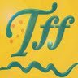
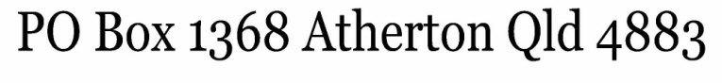
2018 Tablelands Folk Festival “Shine a Light” Project
SAT 27th & SUN 28th OCTOBER 2018
SCHOOLS - EXPRESSION OF INTEREST

SCHOOL NAME
Teacher contact name
Teacher contact email
Teacher contact phone
PERFORMANCE NAME
PERFORMANCE NAME  AND SHORT DESCRIPTION OF ACT | Example: e.g. Jacaranda Primary School Junior Choir would like to present 4 songs
APPROXIMATE LENGTH OF PERFORMANCE
PREFERRED DAY SAT or SUN
APPROX # OF STUDENTS
ANY OTHER NOTES

Please return this form to Jane Younghusband at REACH (Regional Excellence in Arts and Culture Hubs) jyoun185@eq.edu.au or by fax to 4051 5754
PLEASE RETURN THIS EOI BY END OF JULY
(uploaded to TFF website June 2018

